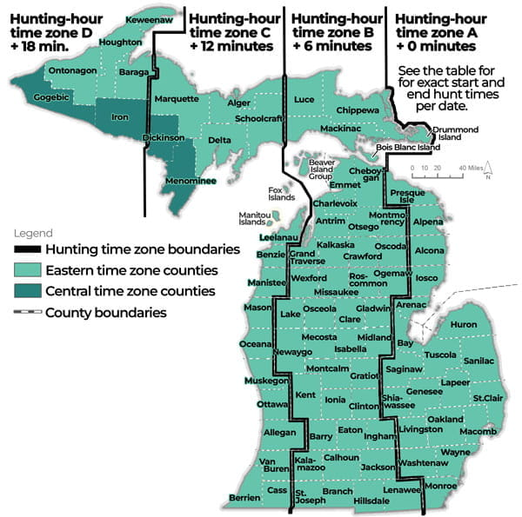

Zone A early teal season hunting hours table (September 2026)
Hunting hours listed for the early teal season are sunrise to sunset (adjusted for daylight saving time).
Date | Time Zone A a.m. | Time Zone A p.m.
Sept. 1 | 6:58 | 8:05
Sept. 2 | 6:59 | 8:03
Sept. 3 | 7:00 | 8:02
Sept. 4 | 7:01 | 8:00
Sept. 5 | 7:02 | 7:59
Sept. 6 | 7:03 | 7:57
Sept. 7 | 7:04 | 7:55
Sept. 8 | 7:05 | 7:54
Sept. 9 | 7:06 | 7:52

Zone A hunting hours table (September – October 2026)
Hunting hours listed are one half-hour before sunrise to sunset (adjusted for daylight saving time).
Date | Time Zone A a.m. | Time Zone A p.m.
Sept. 1 | 6:28 | 8:05
Sept. 2 | 6:29 | 8:03
Sept. 3 | 6:30 | 8:02
Sept. 4 | 6:31 | 8:00
Sept. 5 | 6:32 | 7:59
Sept. 6 | 6:33 | 7:57
Sept. 7 | 6:34 | 7:55
Sept. 8 | 6:35 | 7:54
Sept. 9 | 6:36 | 7:52
Sept. 10 | 6:37 | 7:51
Sept. 11 | 6:38 | 7:49
Sept. 12 | 6:39 | 7:47
Sept. 13 | 6:40 | 7:46
Sept. 14 | 6:41 | 7:44
Sept. 15 | 6:42 | 7:42
Sept. 16 | 6:43 | 7:41
Sept. 17 | 6:44 | 7:39
Sept. 18 | 6:45 | 7:37
Sept. 19 | 6:46 | 7:36
Sept. 20 | 6:48 | 7:34
Sept. 21 | 6:49 | 7:32
Sept. 22 | 6:50 | 7:31
Sept. 23 | 6:51 | 7:29
Sept. 24 | 6:52 | 7:27
Sept. 25 | 6:53 | 7:26
Sept. 26 | 6:54 | 7:24
Sept. 27 | 6:55 | 7:23
Sept. 28 | 6:56 | 7:21
Sept. 29 | 6:57 | 7:19
Sept. 30 | 6:58 | 7:18
Oct. 1 | 6:59 | 7:16
Oct. 2 | 7:00 | 7:14
Oct. 3 | 7:02 | 7:13
Oct. 4 | 7:03 | 7:11
Oct. 5 | 7:04 | 7:10
Oct. 6 | 7:05 | 7:08
Oct. 7 | 7:06 | 7:07
Oct. 8 | 7:07 | 7:05
Oct. 9 | 7:08 | 7:03
Oct. 10 | 7:09 | 7:02
Oct. 11 | 7:11 | 7:00
Oct. 12 | 7:12 | 6:59
Oct. 13 | 7:13 | 6:57
Oct. 14 | 7:14 | 6:56
Oct. 15 | 7:15 | 6:54
Oct. 16 | 7:16 | 6:53
Oct. 17 | 7:17 | 6:51
Oct. 18 | 7:19 | 6:50
Oct. 19 | 7:20 | 6:49
Oct. 20 | 7:21 | 6:47
Oct. 21 | 7:22 | 6:46
Oct. 22 | 7:23 | 6:44
Oct. 23 | 7:25 | 6:43
Oct. 24 | 7:26 | 6:42
Oct. 25 | 7:27 | 6:40
Oct. 26 | 7:28 | 6:39
Oct. 27 | 7:29 | 6:38
Oct. 28 | 7:31 | 6:36
Oct. 29 | 7:32 | 6:35
Oct. 30 | 7:33 | 6:34
Oct. 31 | 7:34 | 6:33

Zone A hunting hours table (November – December 2026)
Hunting hours listed are one half-hour before sunrise to sunset (adjusted for daylight saving time).
Date | Time Zone A a.m. | Time Zone A p.m.
Nov. 1 | 6:36 | 6:32
Nov. 2 | 6:37 | 5:31
Nov. 3 | 6:38 | 5:29
Nov. 4 | 6:39 | 5:28
Nov. 5 | 6:41 | 5:27
Nov. 6 | 6:42 | 5:26
Nov. 7 | 6:43 | 5:25
Nov. 8 | 6:44 | 5:24
Nov. 9 | 6:46 | 5:23
Nov. 10 | 6:47 | 5:22
Nov. 11 | 6:48 | 5:21
Nov. 12 | 6:49 | 5:20
Nov. 13 | 6:51 | 5:20
Nov. 14 | 6:52 | 5:19
Nov. 15 | 6:53 | 5:18
Nov. 16 | 6:54 | 5:17
Nov. 17 | 6:55 | 5:17
Nov. 18 | 6:57 | 5:16
Nov. 19 | 6:58 | 5:15
Nov. 20 | 6:59 | 5:15
Nov. 21 | 7:00 | 5:14
Nov. 22 | 7:02 | 5:13
Nov. 23 | 7:03 | 5:13
Nov. 24 | 7:04 | 5:12
Nov. 25 | 7:05 | 5:12
Nov. 26 | 7:06 | 5:12
Nov. 27 | 7:07 | 5:11
Nov. 28 | 7:08 | 5:11
Nov. 29 | 7:10 | 5:10
Nov. 30 | 7:11 | 5:10
Dec. 1 | 7:12 | 5:10
Dec. 2 | 7:13 | 5:10
Dec. 3 | 7:14 | 5:10
Dec. 4 | 7:15 | 5:09
Dec. 5 | 7:16 | 5:09
Dec. 6 | 7:17 | 5:09
Dec. 7 | 7:18 | 5:09
Dec. 8 | 7:19 | 5:09
Dec. 9 | 7:20 | 5:09
Dec. 10 | 7:20 | 5:10
Dec. 11 | 7:21 | 5:10
Dec. 12 | 7:22 | 5:10
Dec. 13 | 7:23 | 5:10
Dec. 14 | 7:24 | 5:10
Dec. 15 | 7:24 | 5:11
Dec. 16 | 7:25 | 5:11
Dec. 17 | 7:26 | 5:11
Dec. 18 | 7:26 | 5:12
Dec. 19 | 7:27 | 5:12
Dec. 20 | 7:27 | 5:13
Dec. 21 | 7:28 | 5:13
Dec. 22 | 7:28 | 5:14
Dec. 23 | 7:29 | 5:14
Dec. 24 | 7:29 | 5:15
Dec. 25 | 7:30 | 5:15
Dec. 26 | 7:30 | 5:16
Dec. 27 | 7:30 | 5:17
Dec. 28 | 7:31 | 5:17
Dec. 29 | 7:31 | 5:18
Dec. 30 | 7:31 | 5:19
Dec. 31 | 7:31 | 5:20

Zone A hunting hours table (January – February 2027)
Hunting hours listed are one half-hour before sunrise to sunset.
Date | Time Zone A a.m. | Time Zone A p.m.
Jan. 1 | 7:31 | 5:10
Jan. 2 | 7:31 | 5:11
Jan. 3 | 7:31 | 5:12
Jan. 4 | 7:31 | 5:13
Jan. 5 | 7:31 | 5:14
Jan. 6 | 7:31 | 5:15
Jan. 7 | 7:31 | 5:16
Jan. 8 | 7:31 | 5:17
Jan. 9 | 7:31 | 5:18
Jan. 10 | 7:31 | 5:19
Jan. 11 | 7:30 | 5:20
Jan. 12 | 7:30 | 5:21
Jan. 13 | 7:30 | 5:22
Jan. 14 | 7:29 | 5:24
Jan. 15 | 7:29 | 5:25
Jan. 16 | 7:28 | 5:26
Jan. 17 | 7:28 | 5:27
Jan. 18 | 7:27 | 5:28
Jan. 19 | 7:27 | 5:30
Jan. 20 | 7:26 | 5:31
Jan. 21 | 7:25 | 5:32
Jan. 22 | 7:25 | 5:33
Jan. 23 | 7:24 | 5:35
Jan. 24 | 7:23 | 5:36
Jan. 25 | 7:22 | 5:37
Jan. 26 | 7:21 | 5:38
Jan. 27 | 7:21 | 5:40
Jan. 28 | 7:20 | 5:41
Jan. 29 | 7:19 | 5:42
Jan. 30 | 7:18 | 5:44
Jan. 31 | 7:17 | 5:45
Feb. 1 | 7:16 | 5:46
Feb. 2 | 7:15 | 5:47
Feb. 3 | 7:14 | 5:49
Feb. 4 | 7:13 | 5:50
Feb. 5 | 7:11 | 5:51
Feb. 6 | 7:10 | 5:53
Feb. 7 | 7:09 | 5:54
Feb. 8 | 7:08 | 5:55
Feb. 9 | 7:07 | 5:57
Feb. 10 | 7:05 | 5:58
Feb. 11 | 7:04 | 5:59
Feb. 12 | 7:03 | 6:01
Feb. 13 | 7:02 | 6:02
Feb. 14 | 7:00 | 6:03
Feb. 15 | 6:59 | 6:04

